# **Project Requirement Document**

**Chrome Extension – AD User Registration & Management System**

## **1. Purpose**

This document defines the functional and technical requirements for a system that enables user onboarding via a Chrome Extension and administrative user management through a backend integrated with Windows Active Directory (AD).

The primary objective is to:

* Collect Chrome browser user identity
* Track pending users
* Allow an AD-admin to register, manage, and update users and their AD security group memberships

This document is intended for **newly onboarded software engineers**.

## **2. System Overview**

### **High-Level Components**

1. **Chrome Extension**
   * Collects logged-in Chrome user email
   * Communicates with backend APIs
2. **Backend Server**
   * ASP.NET Core application
   * Integrates with Windows Active Directory
   * Manages user lifecycle and group memberships
3. **Active Directory**
   * User authentication
   * Security group validation and management

## **3. User Roles**

### **3.1 Chrome Extension User**

* Identified by Google email retrieved from Chrome
* Initially added to the system with *Pending* status

### **3.2 System Admin (Backend Login)**

* Authenticates using Active Directory credentials
* Must be a member of a **specific AD Security Group**
* Responsible for registering and managing users

## **4. Chrome Extension Requirements**

### **4.1 Identity Collection**

* Use chrome.identity API to retrieve the logged-in Chrome user's email
* Send the email to the backend via a secure API request

### **4.2 Initial User Registration Flow**

1. Chrome extension retrieves Google email
2. Sends email to backend API
3. Backend stores user in database with:
   * status = -1 (Pending)

### **4.3 Technology Constraints**

* Developed using:
  + **Vite**
  + **TypeScript**
* Must follow:
  + Object-Oriented Programming (OOP)
  + Dependency Injection (DI)

## **5. Backend Requirements**

### **5.1 Authentication & Authorization**

* Backend authentication must use **Active Directory**
* Logged-in backend user:
  + Must belong to a predefined AD Security Group
  + Otherwise access must be denied

## **6. Pending User Management (Admin UI)**

### **6.1 Pending Users Table**

After admin login, the system must load all pending users into a table with the following columns:

| **Column Name** | **Description** |
| --- | --- |
| Google Email Address | Email retrieved from Chrome |
| AD User Principal Name | Display N/A if not registered |
| Status | Pending or Registered |
| Delete | Option to delete the user |

## **7. User Details Modal**

### **7.1 Open User Modal**

* Clicking a user row opens a modal window
* Modal loads user details by **User ID**

### **7.2 Modal Content**

* User basic details
* Table of AD Security Groups:
  + Displayed only if groups exist
* Security group selection dropdown:
  + Groups must be loaded from a **specific AD OU**

### **7.3 Password Management**

* Modal must include a button to:
  + **Reset the AD user password**

## **8. User Registration Flow**

### **8.1 Register User**

When user status is **Pending**:

1. Admin selects AD security groups
2. Clicks **Register** button
3. System performs:
   * Adds user to selected AD groups
   * Updates database status to Registered

## **9. User Update Flow**

### **9.1 Update Existing User**

When user status is **Registered**:

* Modal opens in *Update Mode*
* “Register” button must be renamed to **Update**

### **9.2 Update Capabilities**

Admin can:

* Add user to additional AD security groups
* Remove user from existing AD groups
* Submit update request to persist changes
* rESET ad PASSWORD USING A SYSTEM GENERATED PASSWORD

## **10. Delete User**

* Admin can delete a user from the system
* This removes:
  + User record from the backend database
* (Optional / configurable): AD group removal behavior can be defined separately

## **11. Backend Architecture Requirements**

### **11.1 Technology Stack**

* **ASP.NET Core**
* **Clean Architecture**
* **MediatR pattern**
* **Dependency Injection (DI)**

### **11.2 Architectural Layers**

* Presentation (API)
* Application (MediatR handlers)
* Domain
* Infrastructure (AD, DB integrations)

## **12. Non-Functional Requirements**

### **12.1 Security**

* All APIs must be authenticated
* AD credentials must never be exposed to the client
* Chrome extension must communicate over HTTPS

### **12.2 Maintainability**

* Code must be modular and testable
* Clear separation of concerns

## **13. Status Definitions**

| **Status Code** | **Meaning** |
| --- | --- |
| -1 | Pending |
| 1 | Registered |

## **14. Assumptions**

* Active Directory is reachable from backend
* Required OUs and security groups exist
* Admin group name is predefined and configurable
* Keep Ad passwords and DNs inside Environment Variables.

UI Mockups

1. Login screen
   1. 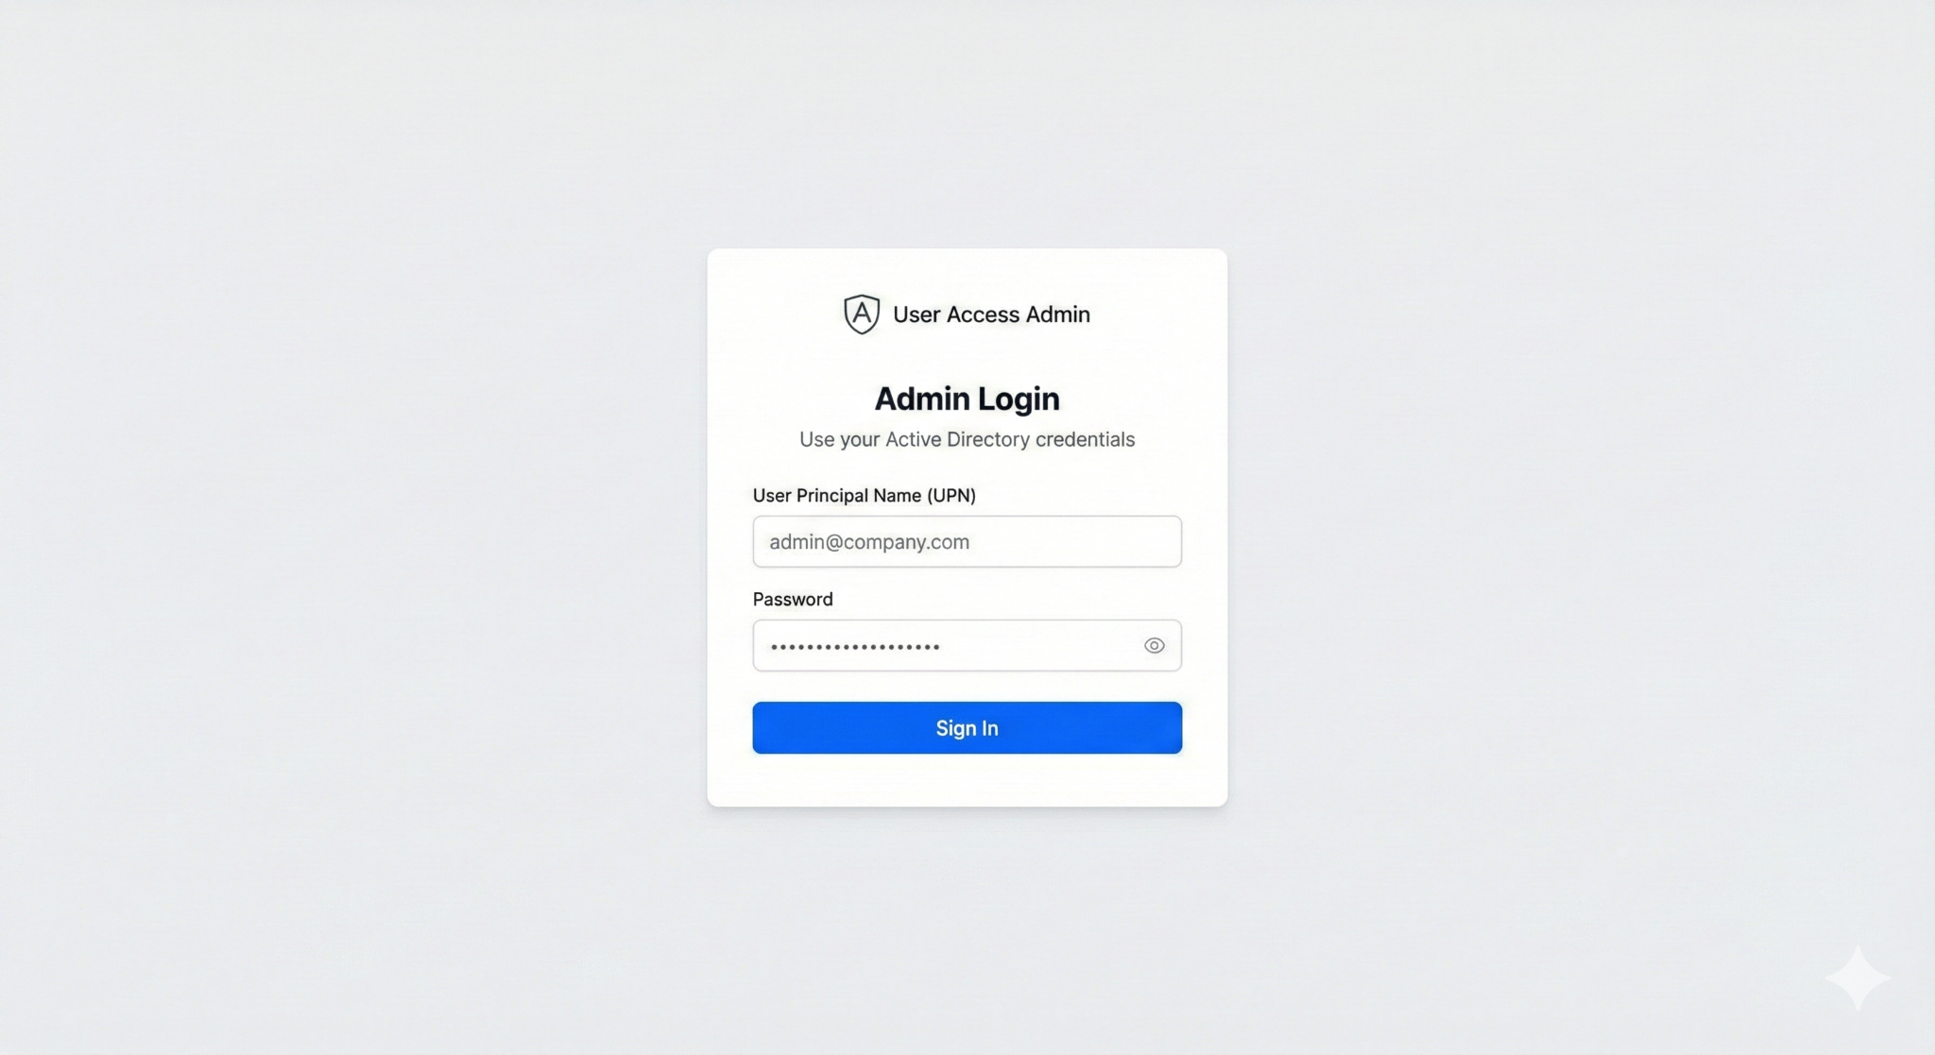
2. Admin dashboard
   1. 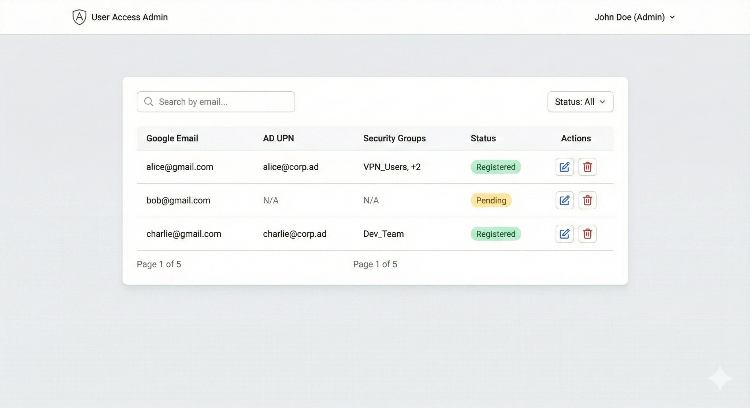
3. Register Modal
   1. 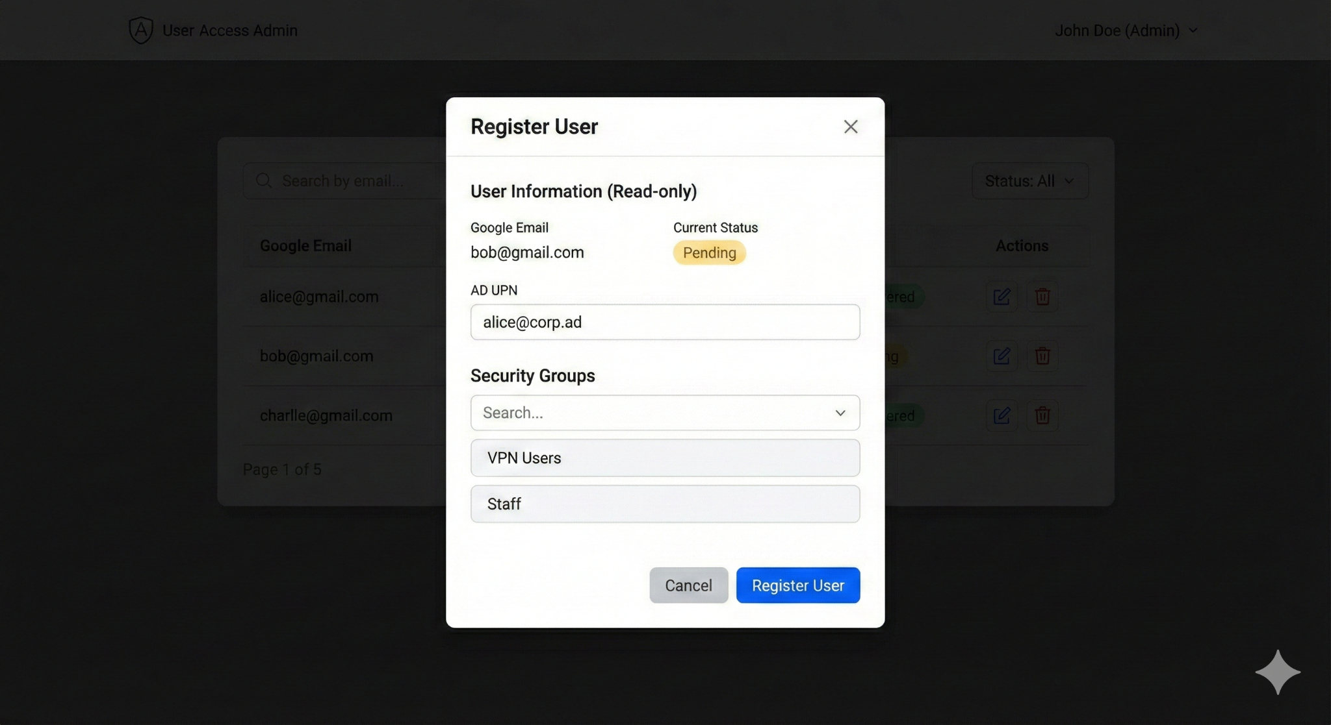
4. Delete Modal
   1. 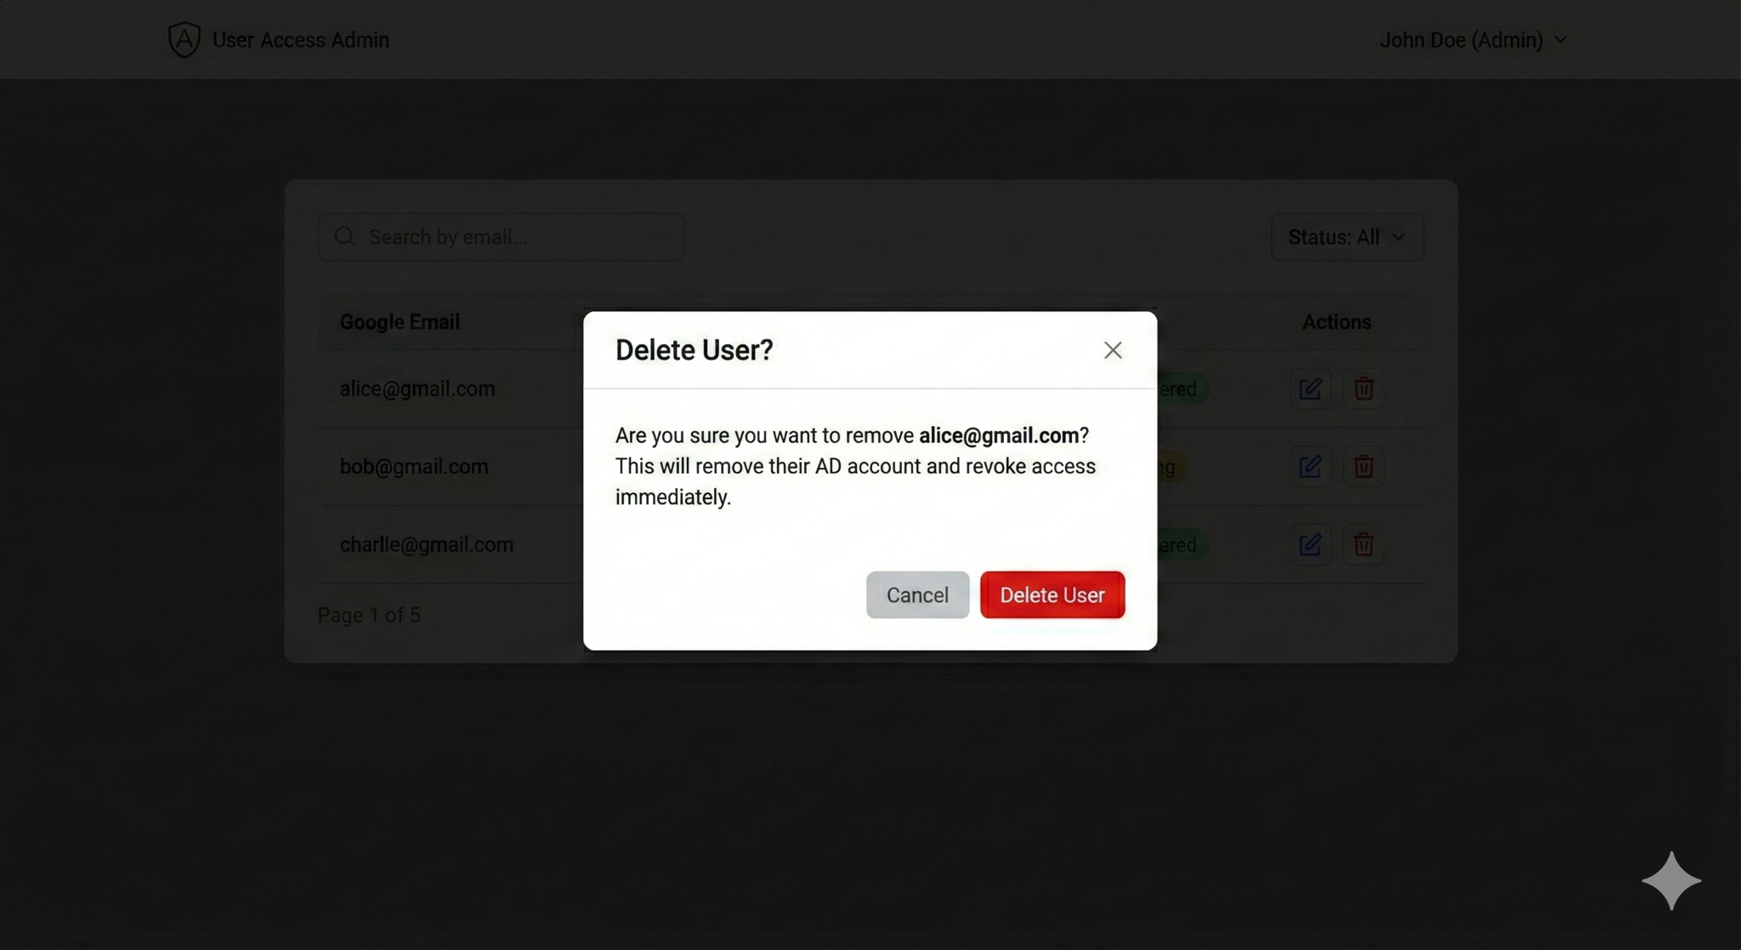
5. Update
   1. 